- Given the following 2-3-4 tree:
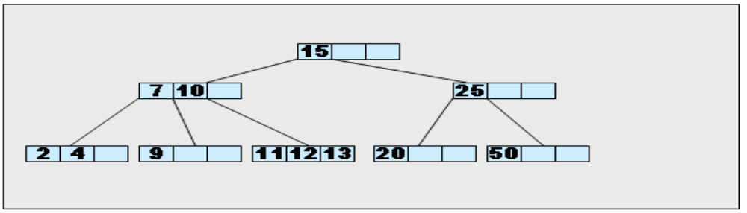
  - Insert 14 into the tree; draw the result.

  - Draw the corresponding red-black tree.

  - Give a sequence of insertions that would create the tree obtained in part b.

50, 25, 10, 20, 15, 7, 12, 4, 9, 11, 13, 1, 14

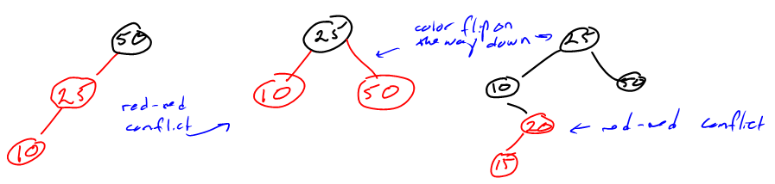

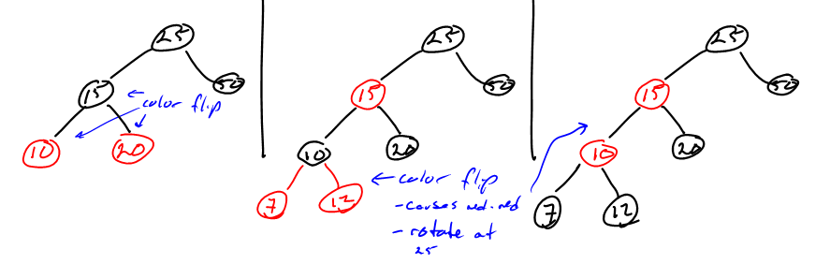
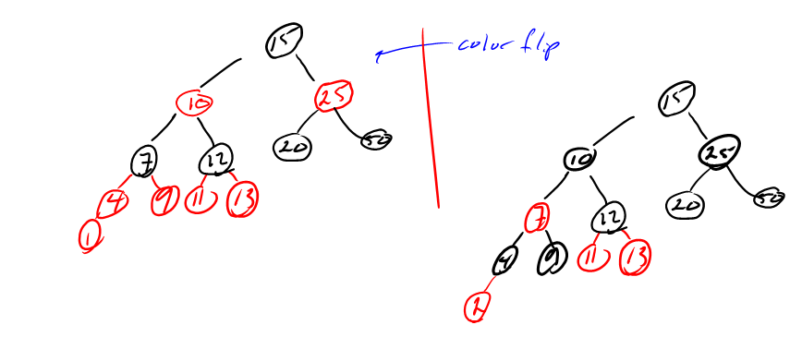

- Encode the following message using a Huffman tree. You will have to build the tree following Huffman’s algorithm discussed in class. Show the resulting tree and the resulting encoded bit sequence.
Message to encode follows in bold (don’t forget that space is a character):
she sells sea shells by the sea shore

s | 8
h | 4
e | 7
l | 4
a | 2
b | 1
y | 1
t | 1
o | 1
r | 1
^(space) | 7
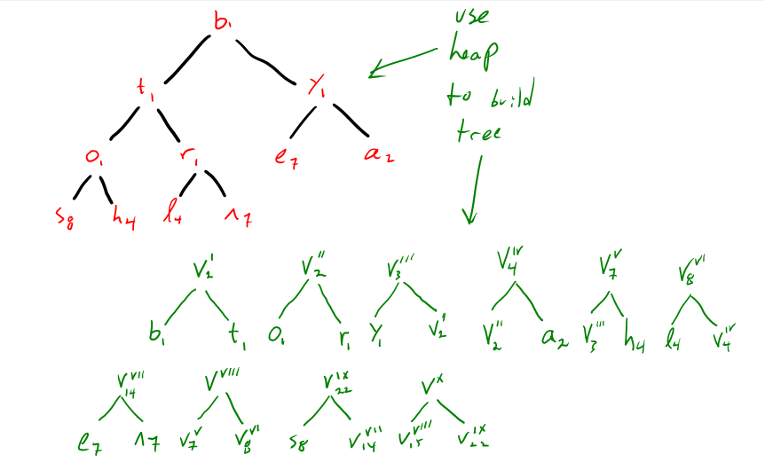

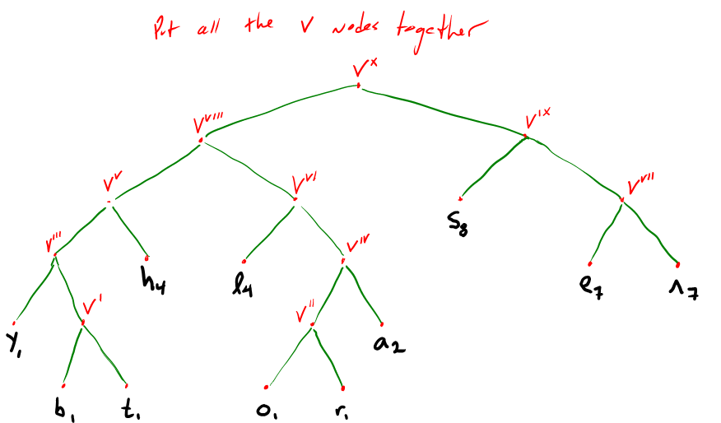

s | 8 | 10
h | 4 | 001
e | 7 | 110
l | 4 | 010
a | 2 | 0111
b | 1 | 00010
y | 1 | 0000
t | 1 | 00011
o | 1 | 01100
r | 1 | 01101
^(space) | 7 | 111

Coded msg.:
she sells sea shells by the sea shore: 1000111011110110010010101111011001111111000111001001010

11100010000011100011001110111101100111111100010110001101110

ASCII: 37 bytes =296 bits
Huffman: 114 bits

Huffman is 61.5% smaller

- Given the initial hash table shown blow, and corresponding hash function 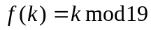:
418 | 0
888 | 1
551 | 2
 | 3
703 | 4
765 | 5
443 | 6
670 | 7
255 | 8
423 | 9
 | 10
999 | 11
 | 12
 | 13
233 | 14
 | 15
843 | 16
776 | 17
 | 18
  - Insert the following integers using linear probing 999, 765, 443, 255, 670
  - Insert the following integers using quadratic probling 423, 233, 843, 418
  - Insert the following integers using double probing (use q=7): 551, 703, 888, 776
  - What is the load factor of the resulting hash table? 13/19=68%

- Use merge-sort to sort the following sequence of integers into ascending order. Show each level of recursion by drawing the division of the sequence into subsets and subsequently how the subsets are merged back into a single sequence.

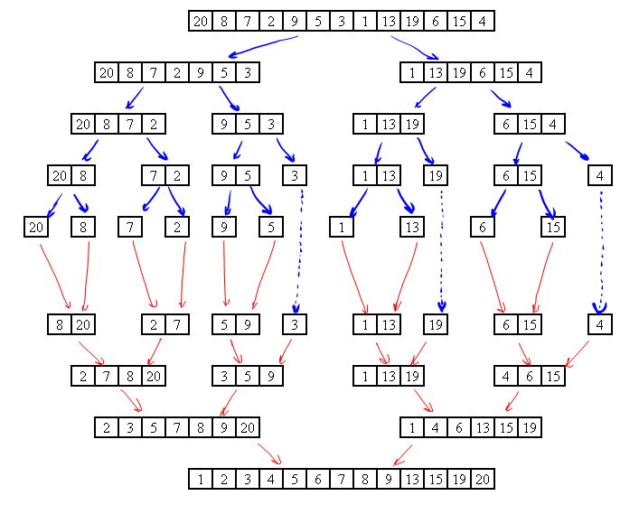

- Perform an in-place QuickSort on the following array. Show the array after each partition step is complete; clearly show the small and large partitions as well as the pivot location after each partition.

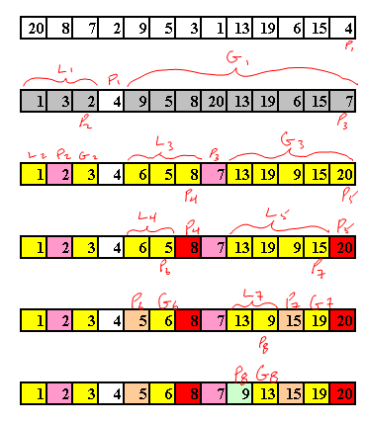

- Implement the in-place QuickSort algorithm given in the class notes. Instead of processing an array of integers, however, your algorithm will process (yes, you guessed it) a doubly-linked list of integers. This includes the partitioning method as well.

Demonstrate that your program works by constructing several linked lists with lengths around 50 containing random integers from the range [0,99]. Each time you sort a list, print the original list then the resulting sorted list.

